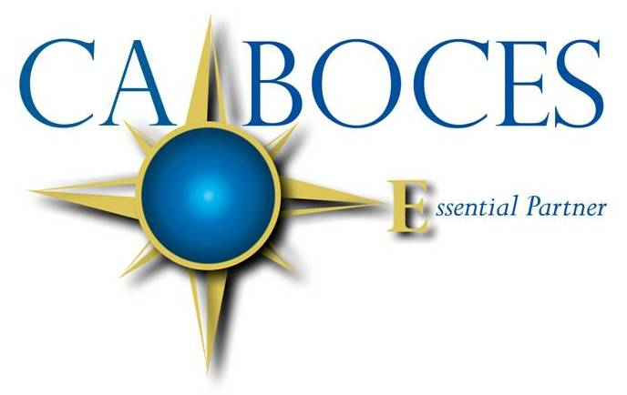
.

Lynda M. Quick
District Superintendent
and Chief Executive Officer

1825 WINDFALL ROAD • OLEAN NY 14760 • 716-376-8200 • www.caboces.org

January 29, 2014

Dear Board President, Members, Superintendent, and Clerk:

Current legislation requires the President of the BOCES Board to name a single date between April 16 and 30 on which all components will meet to vote on the BOCES Administrative Budget and elect BOCES Board members. In compliance with those regulations, the BOCES Board President, Susan Potter set Tuesday, April 22 as the date. Please review your schedule of meetings and consider either moving one of your regular meetings to the 22nd or schedule a special meeting.

This year, three BOCES Board members’ terms will expire. They are Charlie Joyce of Area 1,
Brian Eaton of Area 4, and Brad Sande of Area 9. Area 1 represents Allegany/Limestone and Portville, Area 4 represents Andover, Wellsville and Whitesville, and Area 9 represents Cattaraugus/Little Valley, Randolph and Randolph Academy. BOCES Board members elected to fill the vacancies for Areas 1, 4 and 9 will serve a three-year term.

In order to qualify to be a BOCES Board candidate, individuals:

- Must reside within the boundaries of a component school district. To continue the agreement for area representation, candidates should be residing in the area they will represent.

- Cannot be an employee of a component district.

- No more than one candidate may be elected per component district. A candidate need not be a member of a component district school board to be nominated or elected by that board.

Nominations are by school board resolution and the names of the nominees should be submitted to the BOCES District Clerk, Sally Nenno, BOCES Center at Olean, 1825 Windfall Road, Olean, NY 14760 by March 21, 2014. This information may be hand-carried, mailed, or faxed (716-376-8452).

Election ballots containing the slate of candidates for election to the BOCES Board will be mailed to each component district, by the BOCES Clerk, at least fourteen (14) days prior to the election.

Voting on candidates for election to seats on the BOCES Board will occur on Tuesday, April 22, 2014. Each component board is entitled to cast one vote per vacancy but no more than one vote per candidate. There must be a quorum of board members voting in each district to have a valid ballot. Failure of a component district to obtain a quorum to vote will result in a voided ballot. A component district may not vote on a different date. Any vote cast on a day other than April 22nd will be void.

Voting on the Administrative Budget will occur at the same meeting on April 22nd. Each board is allowed one vote for or against the budget. The Administrative Budget must be approved by resolution of a majority of component districts actually voting. Failure to approve the Administrative Budget will result in a contingency budget being adopted. No second vote can be taken. Each component district must transmit their adopted resolution for the Administrative Budget and their vote for the vacant BOCES seats to the District Superintendent’s office not later than April 23rd which is one business day after the vote.

The 2014 BOCES Annual Meeting has been set for Wednesday, April 2 at 7 p.m. at the Center at Olean. Dinner will be served at 6 p.m. for all board members, administrators, district clerks and others who wish to attend. At this meeting, the various BOCES budgets will be reviewed in detail and opportunities for questions will be offered. Candidates seeking election to the BOCES Board will be afforded an opportunity to speak to his or her candidacy if so inclined. If you plan to attend, please notify your superintendent who will be forwarding the reservations to us no later than March 21, 2014.

Copies of a sample resolution and a certification form for voting on the BOCES budget and a list of BOCES Board members are included for your review. Copies of the 2014-15 tentative budgets will be mailed to your superintendent by March 21, 2014. Each superintendent will distribute the budget to their respective board members.

The entire BOCES Board and staff look forward to seeing you at the Annual Meeting on April 2.

Sincerely yours,
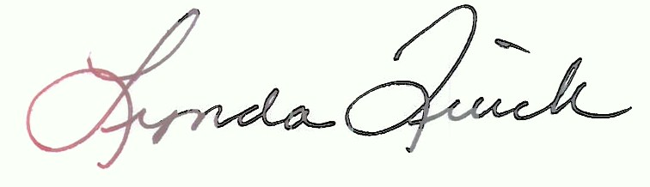

Lynda M. Quick
District Superintendent
san

cc: BOCES Board of Education
Sally Nenno, District Clerk
DLS
Career and Technical Ed. Principals

BOCES ADMINISTRATIVE BUDGET RESOLUTION

RESOLUTION:

Motion by ________________, second by ________________,

to adopt the 2014-2015 Cattaraugus-Allegany-Erie-Wyoming BOCES

Administrative Budget. ____ Ayes, ____ No votes.

CERTIFICATION:

I, ___________________, District Clerk of the ___________________
(Name)
School District do hereby certify that at a public meeting held on

April 22, 2014, the Board of Education of the ____________________

School District _________________________ a resolution adopting the (passed/failed to pass)
2014-2015 Cattaraugus-Allegany-Erie-Wyoming BOCES

Administrative Budget.

___________________________ ___________________
Signature - District Clerk Date
2013-2014
BOARD OF EDUCATION

Board Member | Address | Area | Term Expires
Susan Potter  President | 4545 State Route 19S  Belmont NY 14813 | 2 | 2015
Louis D. Nicol  Vice President | 712 Front Street  Olean NY 14760 | 5 | 2015
Maxine Dowler | 253 State Park Avenue  Salamanca NY 14779 | 8 | 2016
Brian Eaton | 1690 Chipmonk Road  Allegany NY 14706 | 4 | 2014
Gilbert Green | 4328 State Route 305  Cuba NY 14727 | 3 | 2016
Charles Joyce | 4165 Grandview Avenue  Wellsville NY 14895 | 1 | 2014
Robert Keenan | 5112 Steward Road  Hinsdale NY 14743 | 7 | 2016
Dr. Heinke Lillenstein | PO Box 399  Delevan NY 14042 | 6 | 2015
Brad Sande | 115 Fairmont Avenue  Salamanca NY 14779 | 9 | 2014

